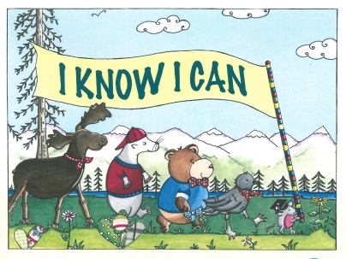
2014-2015 I KNOW I CAN
VOLUNTEERS NEEDED
If you have any questions or to volunteer
Contact: Shelly Morgan at 907-269-7972; shelly.morgan@alaska.gov
Help Inspire Young Alaskans to pursue higher education!
Volunteers will visit second grade classrooms, read the I Know I Can storybook with students and do a fun activity with the class, where students draw pictures of what they want to be when they grow up onto postcards which will be mailed back to them in 2 years.
Total time commitment is 1-1.5 hrs plus a brown bag training orientation Fri. Oct 24 at 12pm.
Volunteer Shifts Currently Available in Anchorage
DATE | TIME | SCHOOL | VOLUNTEERS NEEDED
Wed., Nov. 5 | 9:30am-10:45am | Mountain View Elementary | 2 volunteers
Thurs., Nov. 13 | 8:45am-10:00am | Muldoon Elementary | 2 volunteers
Fri., Nov. 14 | 12:30pm-1:45pm | Creekside Park Elementary | 2 volunteers
Wed., Nov. 19 | 9:15am-10:30am | Susitna Elementary | 2 volunteers
I Know I Can is a partnership activity of the University of Alaska College Savings Plan and Alaska Commission on Postsecondary Education. This program needs volunteers like you!
College is possible – help us continue delivering this important message to Alaska’s children.

